

Mount Wilson White List Manifest Loader Tool

Version: 1.2

Table of Contents

I. Overview 3

II. Installation 3

III. WLM Loader Tool Usage 4

i. Configuration 4

ii. Authentication 5

iii. Retrieving the WLMs 6

# Overview

The White List Manifest (WLM) loader tool is specifically designed to upload the White List Manifests or Good Known Values (GKV) into the Mt.Wilson Database.

Since VMware currently does not provide these GKVs, we will get them from a server that would be built in an isolated environment, which is not tampered.

Note: This tool will currently work only for VMware ESXi 5.1 & ESXi 5.0 hosts running on vCenter 5.1.

# Installation

The WLM loader tool installation package is shipped along with the WLM Portal installation. The installer would be available at “C:\inetput\wwwroot\WLMPortal\WLMLoaderTool\WLMLoaderSetup.msi” if the user has installed at the default location.

Right click on the MSI file and choose the “install” option. You can keep the defaults and complete the setup.

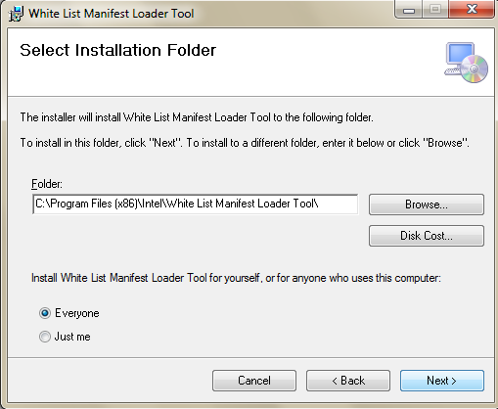

After successful installation, you would find the tool under Start -> All Programs -> Intel WLM Loader Tool

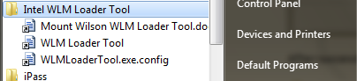

# WLM Loader Tool Usage

## Configuration

In order to use the tool, we first need to setup the configuration settings. Go to the installation location, and edit the WLMLoaderTool.exe.config file. You fill find the below default settings. You can even use the short cut added in the under Start->All Programs.

The “DB_Connection_String” should point to the “mw_as” database that the WLM Portal is configured to use. This tool will use this connection string to authenticate the user using the tool and also upload the GKVs.

In case the user wants to just create the report as an XML file without updating the backend database, he/she can set the “UpdateDB” flag to “False”. By default it would be “True”.

The “ReportFolder” configures the location where you want to store the temporary reports if needed by the user. If in case the folder that the “ReportFolder” setting is pointing to does not exist, then the directory would be created by the tool itself.

The BIOS_MLE_PCR_List is a comma separated string that defines all the PCRs which the good known values need to be updated to the DB for BIOS attestation.

The VMM_MLE_PCR_List is comma separated string that defines all the PCRs for which the good known values need to be updated to the DB for VMM attestation.

The UpdateLocationMapping Boolean flag indicates whether we need to store the mapping of the PCR 22 hash value as a user defined location in the database. If the user has set this flag to true, then the PCR 22 hash value of the host would be mapped to the location information that the user would provide in the tool.

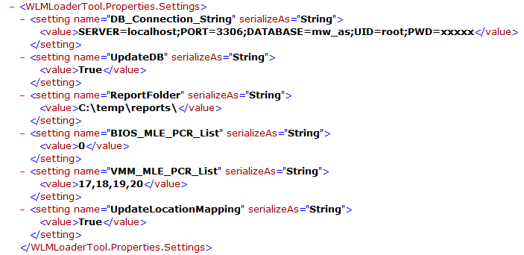

## Authentication

Run the loader tool by executing “WLMLoaderTool.exe” file. The tool is integrated with the Mt. Wilson database for authenticating the users using the tool. Using the same pre-configured login id and password that was used for the WLM portal, authenticate to the tool when prompted for.

The database field displays the database against which the user would be authenticated. This is a non-editable field. The user has to update the .config file to change the database.

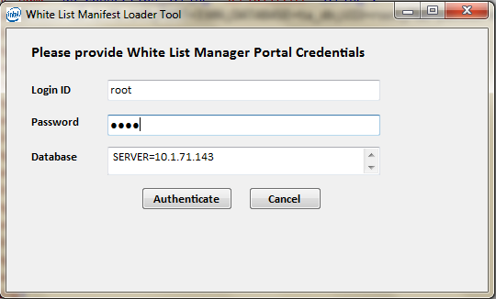

If in case the user enters a wrong id or password, an appropriate message would be displayed.

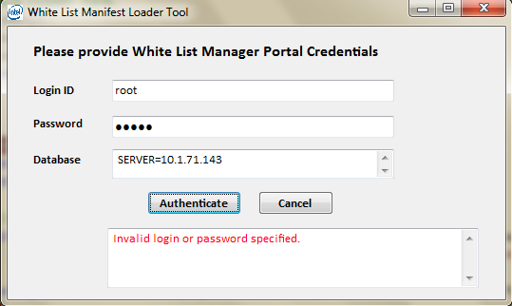

Upon successful authentication, the tool displays the page, where the user has to enter additional information to retrieve the GKVs or WLM from the server.

## Retrieving the WLMs

After successful authentication, user is presented with the below form.

If the user has configured the BIOS MLE List in the configuration file, then all the BIOS MLEs configured in the database would be shown to the user. The user can select from the list for which the associated GKVs would be loaded by the tool.

The user also should select the ESXi MLE for which the GKVs should be loaded along with the ESXi host and vCenter details.

In case the TPM is configured with the location information, then the PCR 22 would be populated with the hash value of the location. If in case the user wants to store the PCR 22 hash value along with the location name, he/she can provide the location name in the “Map Location Value To” field.

Optionally, the user can even choose to save the WLMs into an XML file. The name of the file is auto-generated, which will be shown to the user after successfully updating the database.

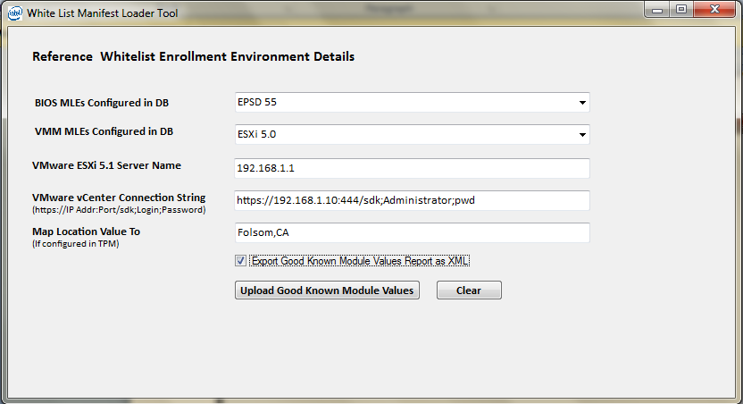

After successfully updating the database, the following message is displayed to the user.

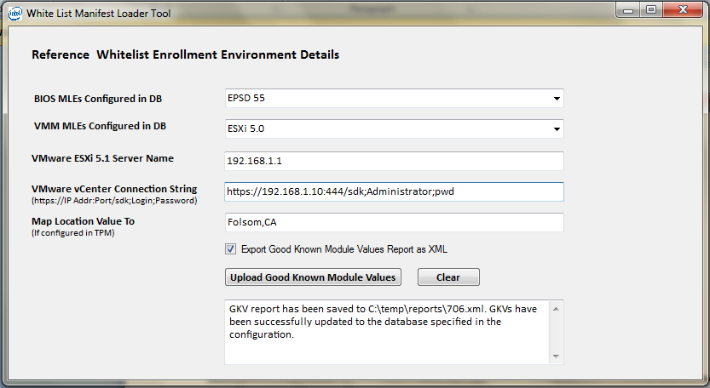

The database update with the good known values can be verified by checking the contents of the “tbl_pcr_manifest” and “tbl_module_manifest”. Each of these tables will have entries for the MLEs (BIOS MLE and VMM MLE) that was configured in the tool earlier.

Note that there will not be any entries added into the “tbl_module_manifest” if the host is of ESXi 5.0. However for both ESXi 5.0 and 5.1, there will be 4 entries in the “tbl_pcr_manifest” table as shown below.



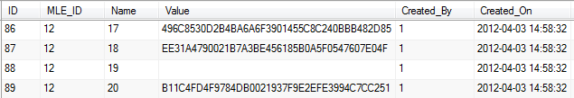

For ESXi 5.1 hosts, there will be about 70 new records added into the “tbl_module_manifest” table.

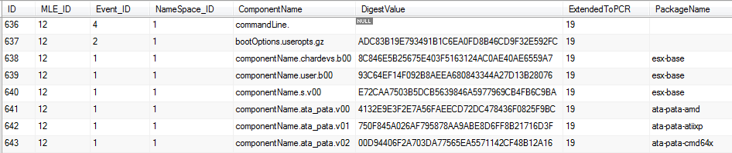

The location information would be added to the tbl_location_pcr table as shown below.



After running this tool successfully, users will be able add Host(s) in the demo portal and associate them with the MLE for which the white list was updated in the database for trust attestation.

Below is the snapshot of the white lists in the XML format that was saved by the tool.

